 | Graduation Project  Initial Submission  Google Data Analyst Specialist  CLS ONL2_DAT1_G2 |  | 
Sponsorship
Ministry of Communications and Information Technology
(MCIT) Egypt

Digital Egypt Pioneers Initiative
DEPI

Project Idea 6: (Outstanding)
UK Train Rides.

Supervised by
Dr. Yasser A. Rahman

Prepared by: Elite Team
Ahmed Hussein Ali Mustafa
Fatma Alzahraa Galal Abd-elsalam Soliman
Heba Tallah Talaat Ezzat Ibrahim
Kareman Mohamed Mahmoud Awad

 | Graduation Project  Initial Submission  Elite Team |  | 



 | Graduation Project  Initial Submission  Elite Team |  | 

Project: Project Idea 6: (Outstanding) UK Train Rides.

1. Team Name: Elite Team

2. Selected Project: Project Idea 6: (Outstanding): UK Train Rides.
3. Team Leader: Ahmed Hussein Ali Mustafa

The group:
No. | Full Name  in English | Full Name in Arabic | Student ID | Education Background | Governorate
1 | Ahmed Hussein Ali Mustafa | أحمد حسين علي مصطفى | 21090350 | MBA + Bachelor of commerce in accounting | Suez
2 | Fatma Alzahraa Galal Abd-elsalam Soliman | فاطمة الزهراء جلال عبد السلام | 21090461 | Bachelor of Pharmacy | New Valley
3 | Heba Tallah Talaat Ezzat Ibrahim | هبه الله طلعت عزت ابراهيم | 21077992 | Master's degree in science + bachelor’s degree in science | Suez
4 | Kareman Mohamed Mahmoud Awad | كاريمان محمد محمود عوض | 21090780 | Bachelor of engineering | Gharbia

Tools Selected: Excel, Power Bi, Tableau and SQL.

Build Data Model, Data Cleaning and Preprocessing

We selected tools like : Excel, Power Bi, Tableau and SQL.

1- we replace values of Signal failure with Signal Failure

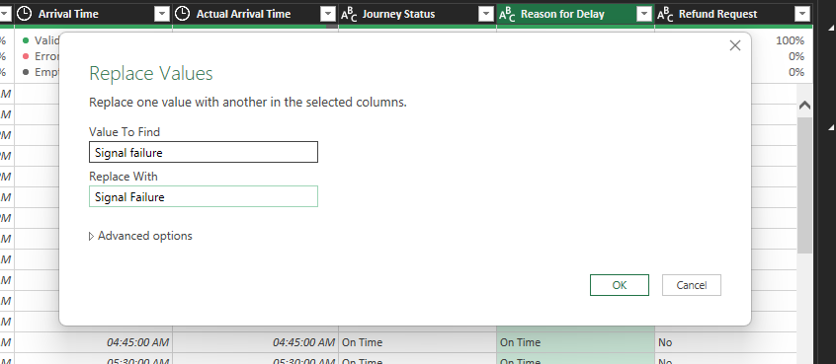

2- we replaced value of Edinburgh with Edinburgh Waverley to unify station names
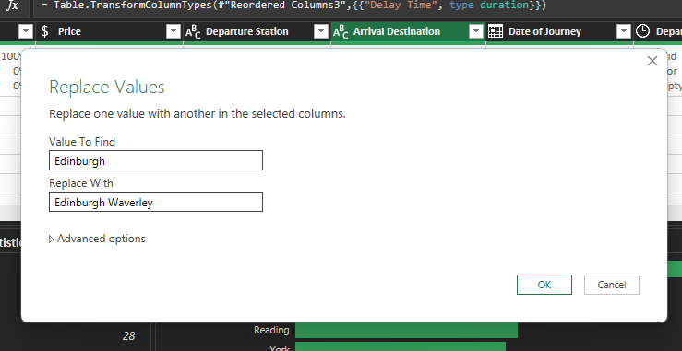
3- A screen of applied steps in query per column, like:
Replaced values, removed duplicated, removed errors, trimmed text and cleaned text
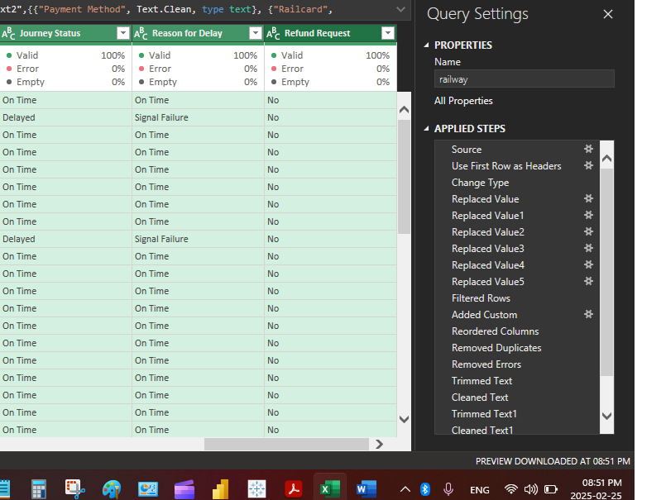
4- We added a new column “Actual Arrival Time” to be calculated by:
if [Actual Arrival Time] = null then [Arrival Time] else [Actual Arrival Time]
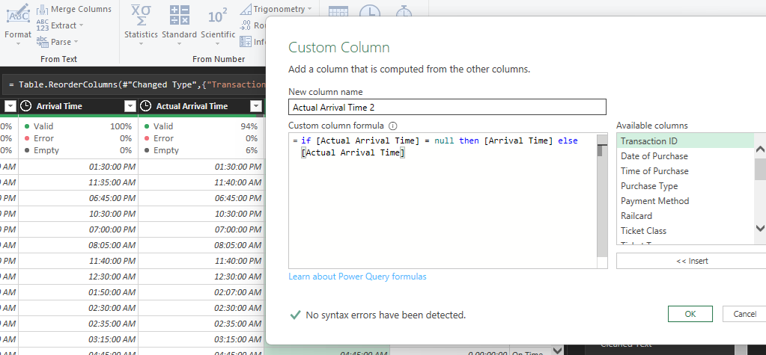
5- We added a new column “Delay Time” to be calculated by:

[Actual Arrival Time] - [Arrival Time]

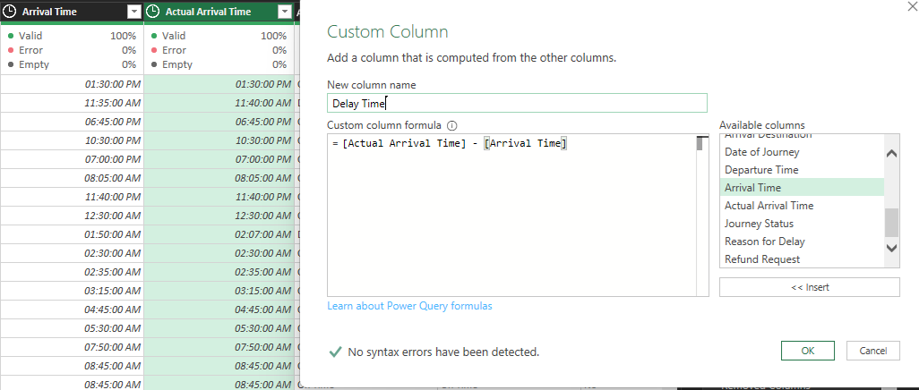

6- We replaced all columns names to be shortcuts names :

Ex 1 : Replaced column name from : “Delay Time” to be : “delay_time”

Ex 2 : Replaced column name from : “Actual Arrival Time” to be “actual_arrival_time”

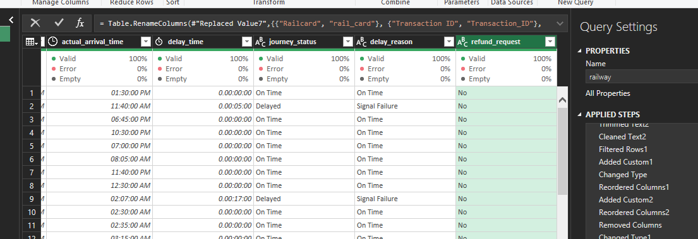

7- We created new calculated field “net revenue” to exclude the influence of refund requests from actual revenues:
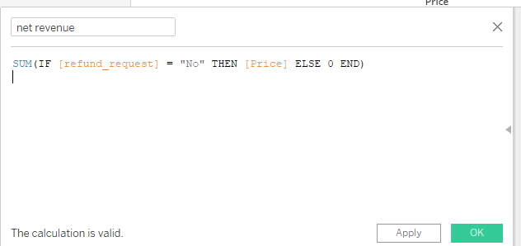

Creating the database:

SQL code:

create database UKTrainRides;

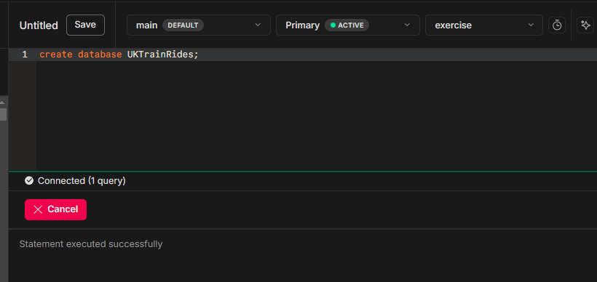

Creating the table railway:
Notes : transaction_id will be VARCHAR not INT because transaction_id column includes letters and special characters ( non-numeric or variable-length )
CREATE TABLE railway (
transaction_id VARCHAR(50) NOT NULL PRIMARY KEY,
purchase_date DATE NOT NULL,
Purchase_time TIME NOT NULL,
purchase_type VARCHAR(50) NOT NULL,
payment_method VARCHAR(50) NOT NULL,
rail_card VARCHAR(50),
ticket_class VARCHAR(50) NOT NULL,
ticket_type VARCHAR(50) NOT NULL,
price DECIMAL(10, 2) NOT NULL,
departure_station VARCHAR(100) NOT NULL,
arrival_destination VARCHAR(100) NOT NULL,
journey_date DATE NOT NULL,
departure_time TIME NOT NULL,
arrival_time TIME NOT NULL,
actual_arrival_time TIME,
delay_time INTERVAL,
journey_status VARCHAR(50) NOT NULL,
delay_reason VARCHAR(50),
refund_request BOOLEAN DEFAULT FALSE
);
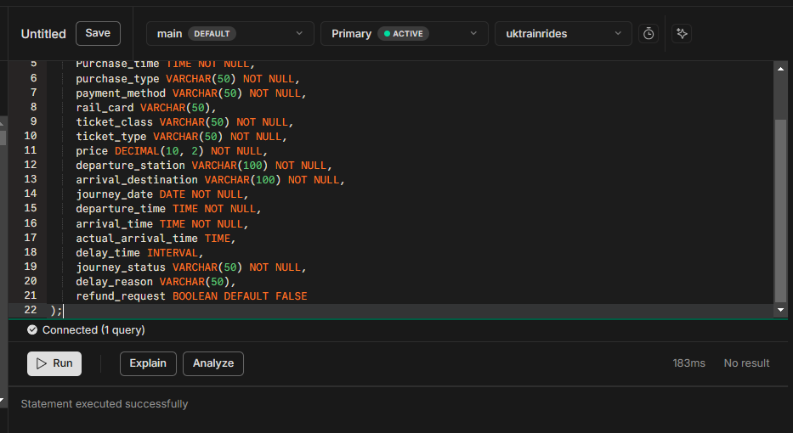
Uploading our data to table : railway
We converted data from excel to sql using table convert website:

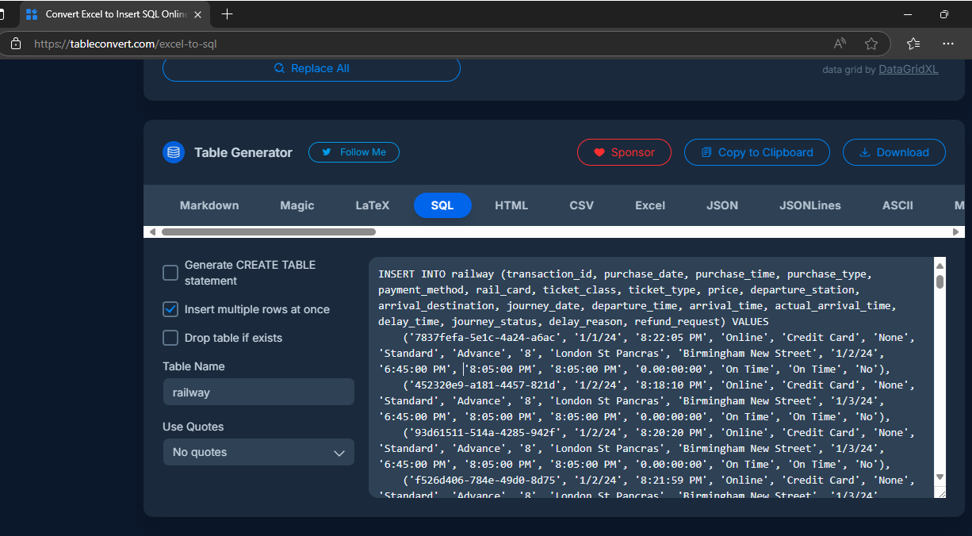

Results of Inserting data into table railway:
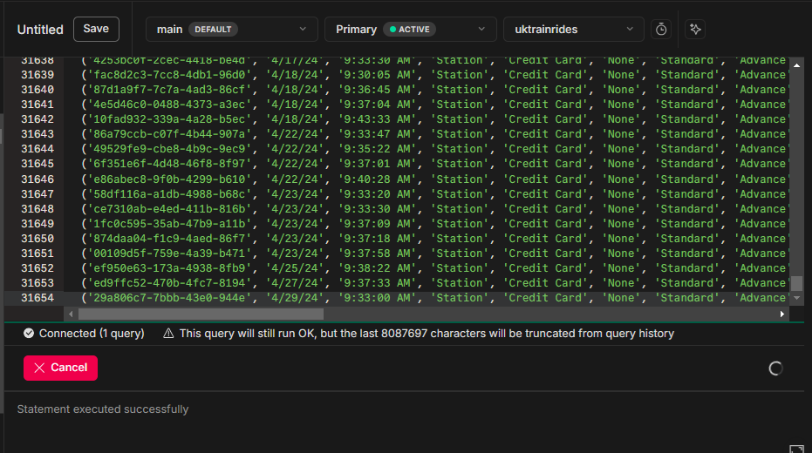

Business Questions:

1. Operational Efficiency:
● What is the overall on-time performance of train journeys?
SELECT
COUNT(*) AS total_journeys,
SUM(CASE WHEN journey_status = 'On Time' THEN 1 ELSE 0 END) AS on_time_journeys,
ROUND(
(SUM(CASE WHEN journey_status = 'On Time' THEN 1 ELSE 0 END) * 100.0 / COUNT(*)), 2) || '%' AS on_time_percentage
FROM railway;
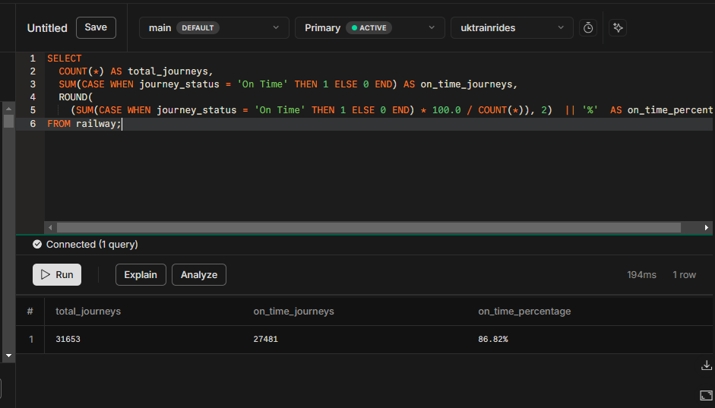
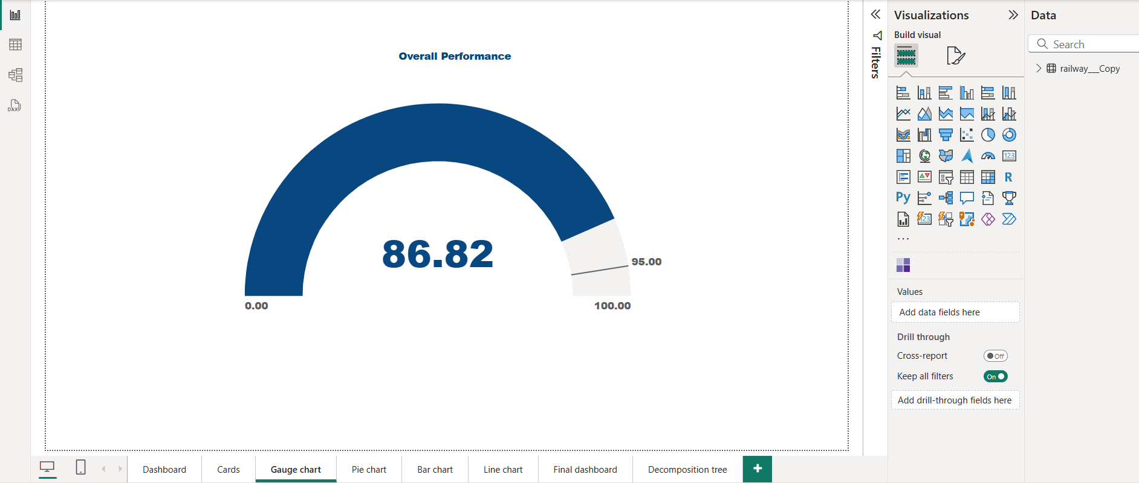
● How many journeys were delayed, percentage and what were the reasons? And determine the effect on refund requests ?
- journeys were delayed & its percentage:
SELECT
COUNT(*) AS total_journeys,
SUM(CASE WHEN journey_status = 'Delayed' THEN 1 ELSE 0 END) AS Delayed_journeys,
ROUND(
(SUM(CASE WHEN journey_status = 'Delayed' THEN 1 ELSE 0 END) * 100.0 / COUNT(*)), 2) || '%' AS Delayed_percentage
FROM railway;
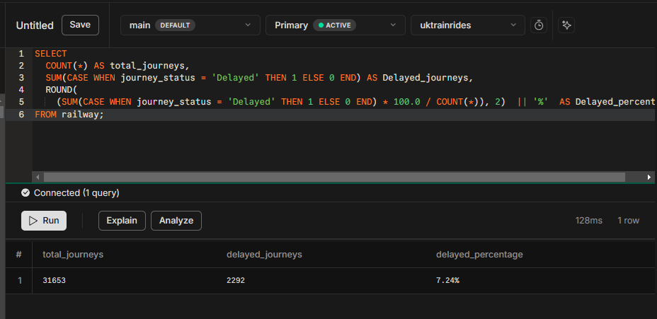
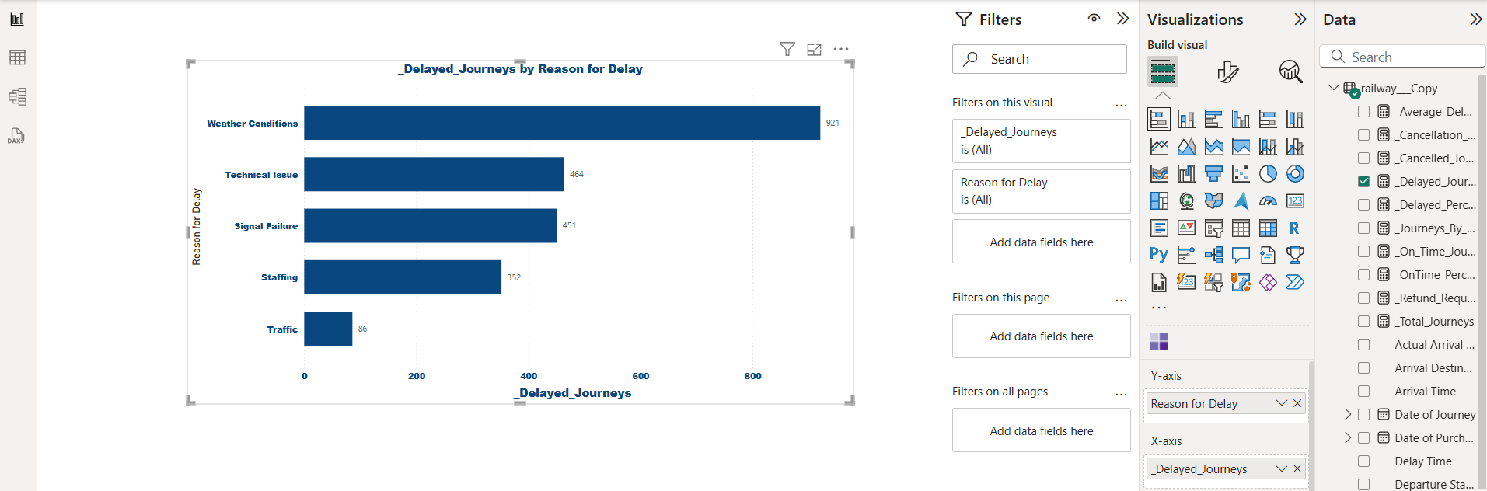

- The reasons and determine the effect on refund requests
SELECT delay_reason,
COUNT(*) AS journey_delayed,
SUM(CASE WHEN refund_request = true THEN 1 ELSE 0 END) AS refund_requested,
CONCAT(ROUND((SUM(CASE WHEN refund_request = true THEN 1 ELSE 0 END) * 100.0 / COUNT(*)), 2), '%') AS refund_percentage
FROM railway
WHERE journey_status = 'Delayed'
GROUP BY delay_reason
ORDER BY journey_delayed DESC;
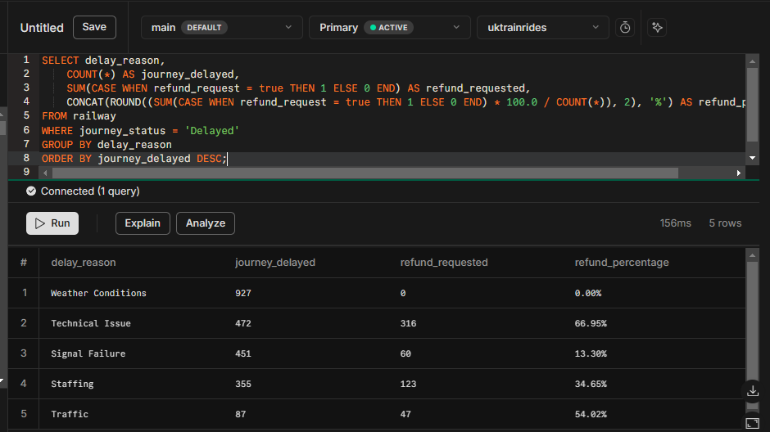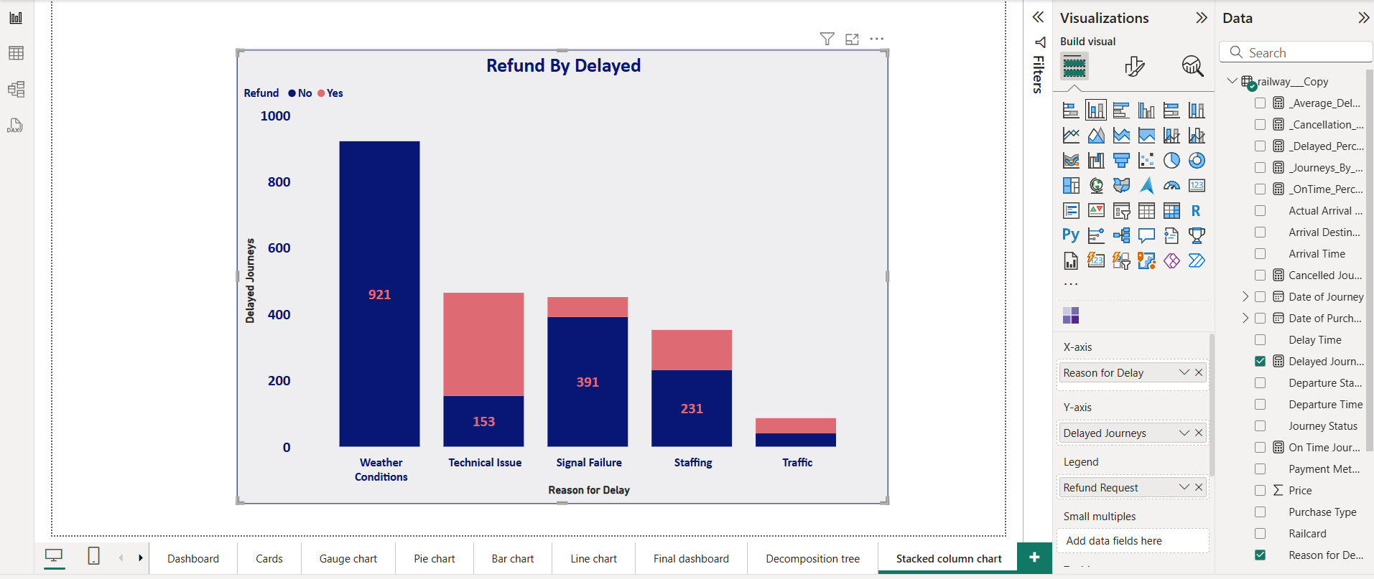
● How many journeys were cancelled? What is its percentage ?
SELECT
COUNT(*) AS total_journeys,
SUM(CASE WHEN journey_status = 'Cancelled' THEN 1 ELSE 0 END) AS Cancelled_journeys,
ROUND(
(SUM(CASE WHEN journey_status = 'Cancelled' THEN 1 ELSE 0 END) * 100.0 / COUNT(*)), 2) || '%' AS Cancelled_percentage
FROM railway;
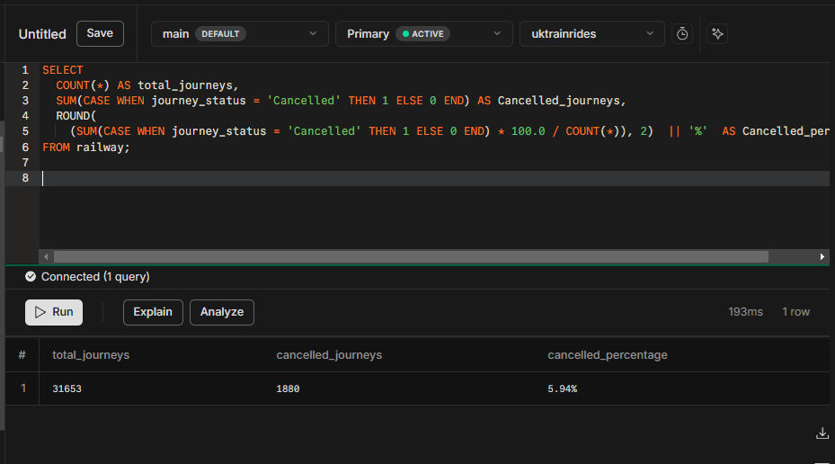
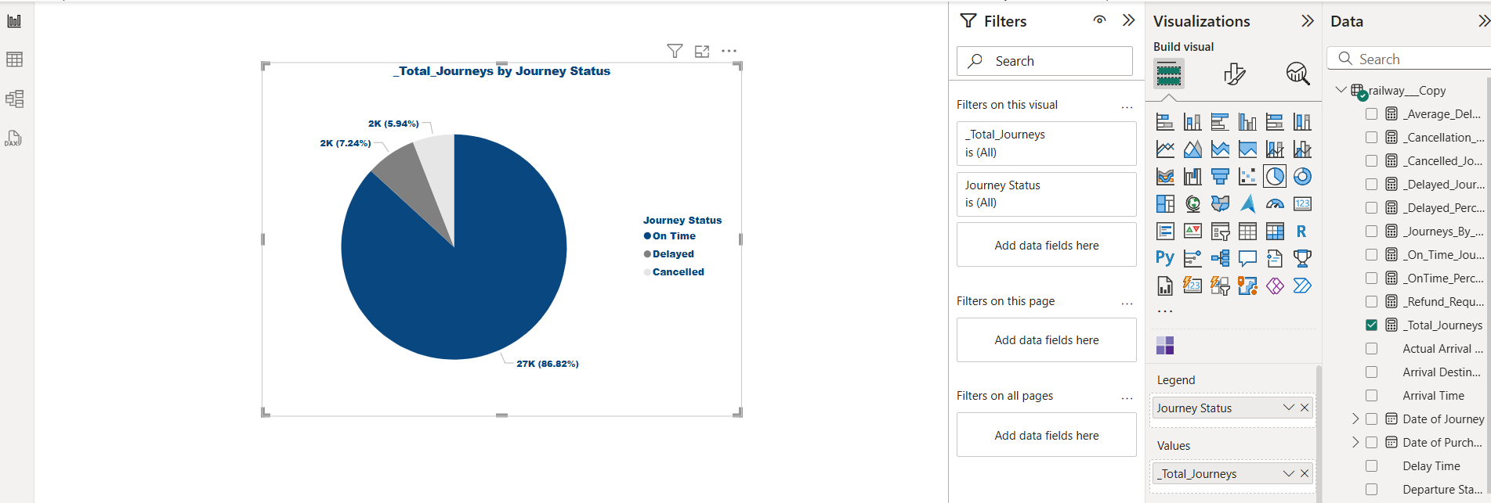
● What are the most popular departure stations?
SELECT
departure_station,
COUNT(*) AS total_journeys
FROM railway
GROUP BY departure_station
ORDER BY total_journeys DESC;
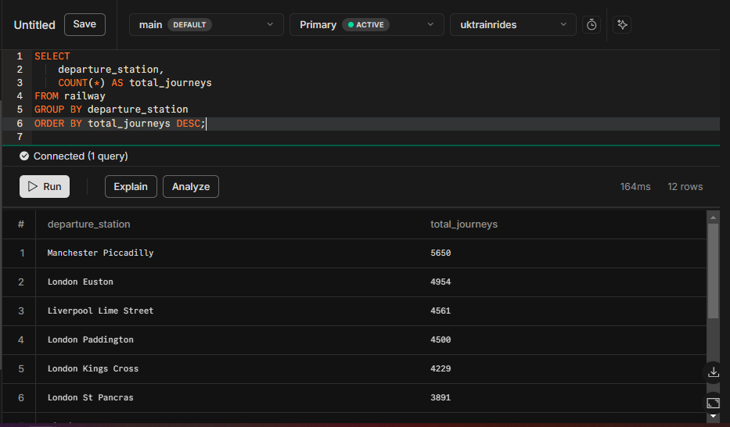
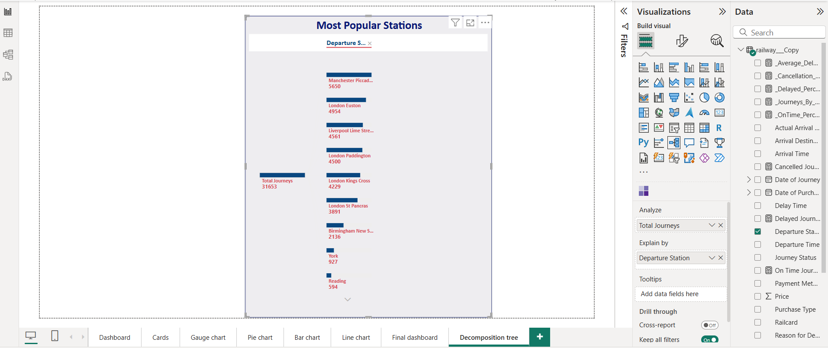

● What is the effect of weather conditions on all train journeys?
SELECT
delay_reason,
SUM(CASE WHEN journey_status = 'Delayed' THEN 1 ELSE 0 END) AS delayed_journeys,
MAX(delay_time) AS max_delay,
SUM(CASE WHEN journey_status = 'Cancelled' THEN 1 ELSE 0 END) AS cancelled_journeys
FROM
railway
WHERE
delay_reason = 'Weather Conditions'
GROUP BY
delay_reason;
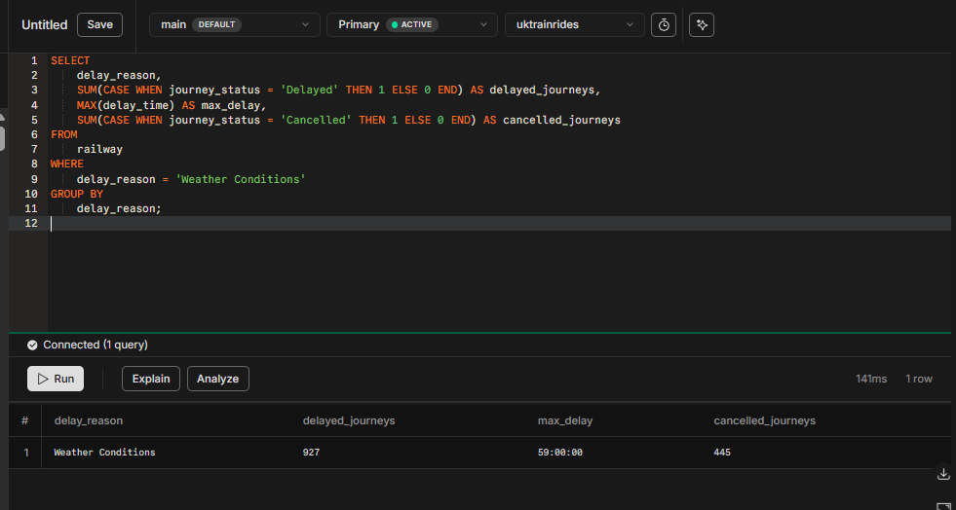


2. Financial Analysis:
● What is the total revenue generated from ticket sales?
SELECT
SUM(price) AS total_revenue
FROM
railway
WHERE
refund_request = 'No';
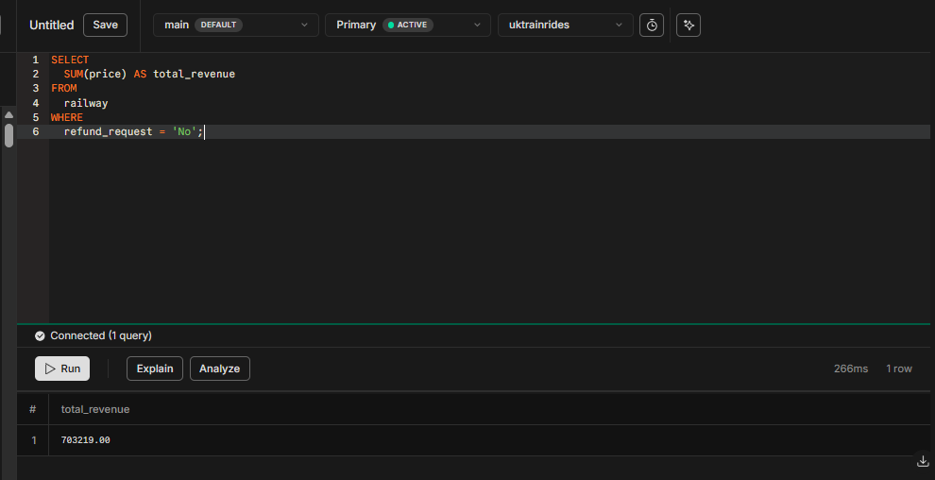
Total Revenue Generated:
Journey Status | Incoming | Refund | Net
On Time | 569,651 | 0 | 569,651
Delayed | 126,814 | 26,165 | 100,649
Cancelled | 45,456 | 12,537 | 32,919
total | 741,921 | 38,702 | 703,219

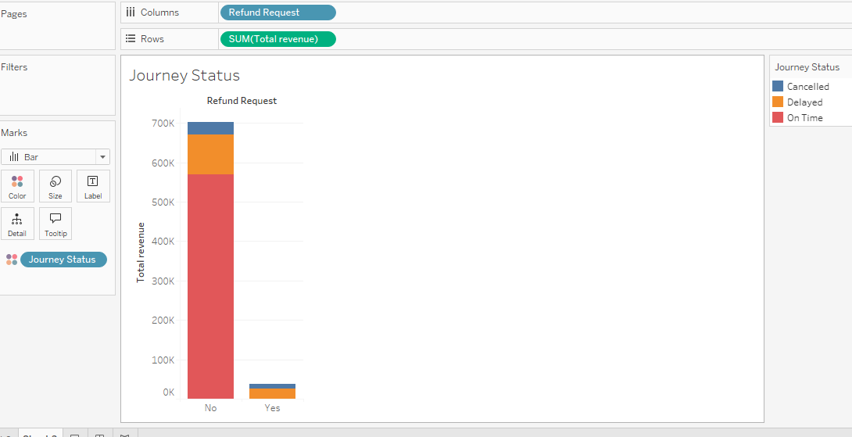
Key Insights

- Total incoming revenue is £741,921, but we have already refunded £38,702 to some customers whose journeys were delayed or cancelled, while the remaining refunds amount to £133,568 (£100,649 delayed + £32,919 cancelled)
- On-time journeys represent the majority, with 569,651 completed without any refunds, contributing 76,78% of the total net journeys.
- Delayed journeys accounted for 126,814, with 26,165 refunded, reducing the net total to 100,649.
- Cancelled journeys were the least frequent, with 45,456 incoming and 12,537 refunded, leaving 32,919 net journeys.
- The total number of incoming journeys was 741,921, with 38,702 refunded, resulting in 703,219 net journeys.

Conclusion & Recommendations
- According to the Conservatism Principle, the amount of £133,568 should not be recognized as “Actual revenue” but should be recorded as “Deferred revenue” until customers request a refund of their advanced payments.
- Delayed journeys (17.09%) resulted in substantial refunds; strategies to improve punctuality could help minimize losses.
- Cancelled journeys (6.12%) also contributed to refunds. Reviewing cancellation reasons and implementing preventive measures can enhance service reliability.
- The high percentage of on-time journeys (76.78%) indicates strong operational efficiency. However, continuous monitoring is essential to maintain this performance.
● Which ticket class (Standard, First Class) generates the most revenue?
SELECT
ticket_class,
SUM(price) AS total_revenue
FROM
railway
WHERE
refund_request = 'No'
GROUP BY
ticket_class
ORDER BY
total_revenue DESC;
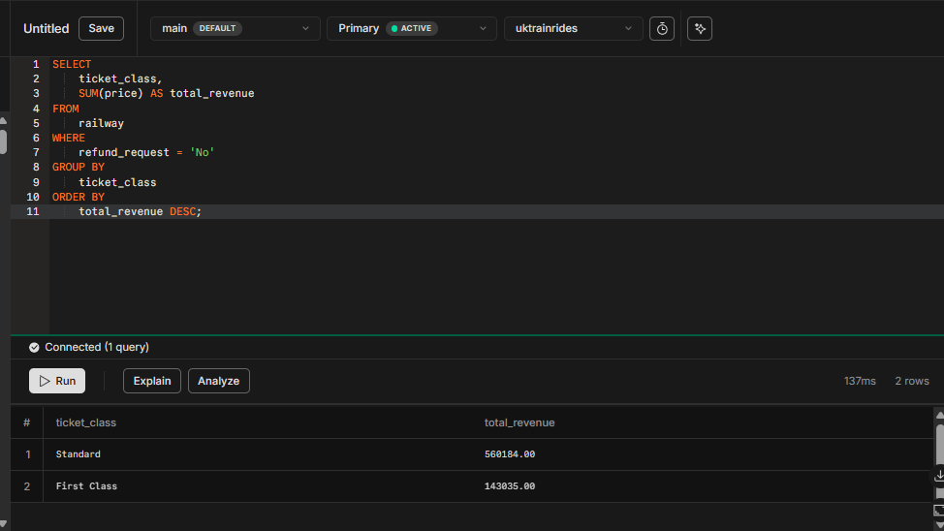

Ticket Class | Number of Transactions | Revenue  £
Standard | 27,590 | 560,184
First Class | 2,945 | 143,035
total | 30,535 | 703,219

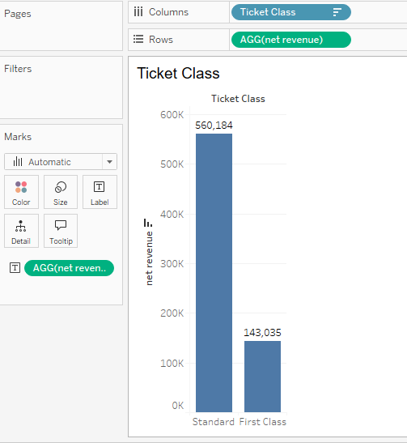
Key Insights:
- Revenue Contribution: Standard Class generates (£560,184) 79.66% of total revenue , while First Class contributes (£143,035) 20.34%.
- Transaction Volume: Standard Class accounts for 90.35% of total transactions (27,590), whereas First Class represents only 9.64% (2,945).
- Revenue per Transaction: First Class yields £48.57 per transaction, significantly higher than Standard Class at £20.30 per transaction.

Conclusion & Recommendations:
- Premium Class Strategy: Enhance First Class offerings (e.g., exclusive services, loyalty perks) to increase transaction volume.
- Targeted Marketing: Develop upselling strategies to encourage Standard Class passengers to upgrade to First Class.

● Which railway routes generate the highest revenue ?
SELECT
CONCAT(departure_station, ' → ', arrival_destination) AS route,
SUM(price) AS total_revenue
FROM
railway
WHERE
refund_request = 'No'
GROUP BY
route
ORDER BY
total_revenue DESC;
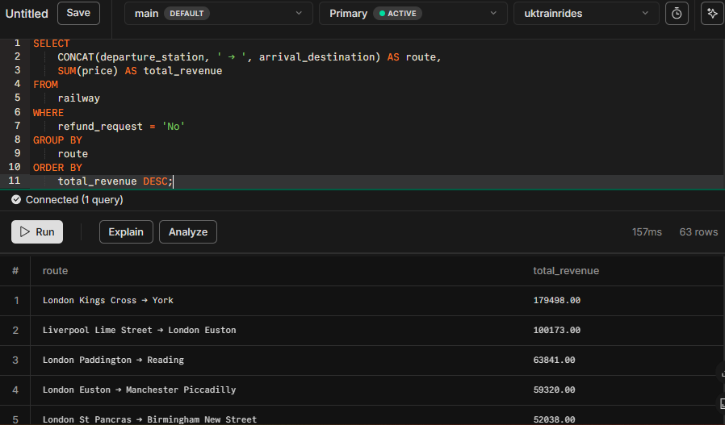
● How do different payment methods correlate with ticket purchases?
SELECT
payment_method,
COUNT(*) AS tickets_count,
SUM(price) AS total_revenue
FROM
railway
WHERE
refund_request = 'No'
GROUP BY
payment_method
ORDER BY
tickets_count DESC;
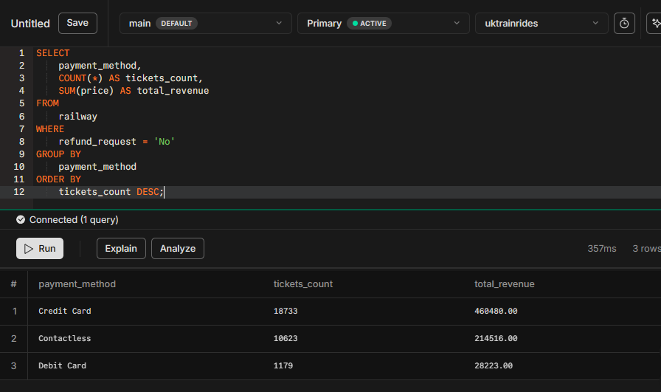

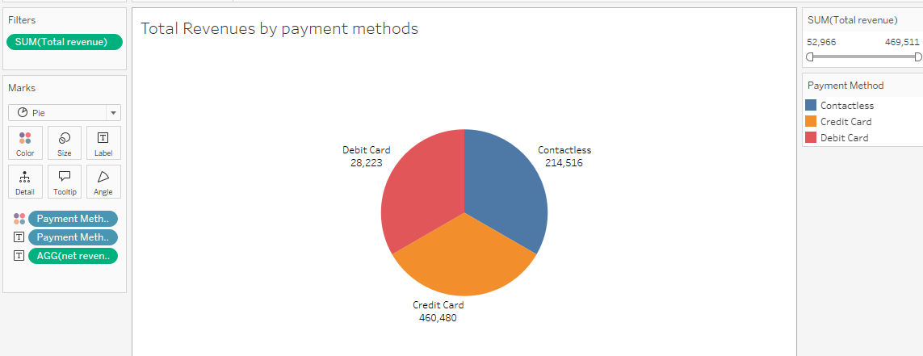

Key Insights:
- Credit Card payments account for the highest number of transactions, £18,733 and generate the highest revenue £460,480, contributing 65.48% of total revenue.
- Contactless payments are the second most used method, with 10,623 transactions, generating £214,516, which represents 30.50% of the total revenue.
- Debit Card payments have the lowest usage, with only 1,179 transactions, generating £28,223, contributing 4.01% to the total revenue.
Conclusion & Recommendations
- Contactless payments are becoming increasingly popular and should be further promoted to enhance customer convenience and transaction speed.
- Credit Card transactions remain the primary revenue driver, and any initiatives aimed at optimizing this payment method could further boost revenue.
- Debit Card transactions are relatively low; strategies to encourage more usage, such as offering incentives, could be explored.

● What are the peak hours for train travel, and how do they impact revenue?
Answer:
Morning Peak (6-8 AM)
Evening Peak (4-6 PM)
SELECT
EXTRACT(HOUR FROM departure_time) AS hour_of_day,
COUNT(*) AS ticket_count,
SUM(price) AS total_revenue
FROM
railway
WHERE
refund_request = 'No'
GROUP BY
hour_of_day
ORDER BY
ticket_count DESC
LIMIT 6;
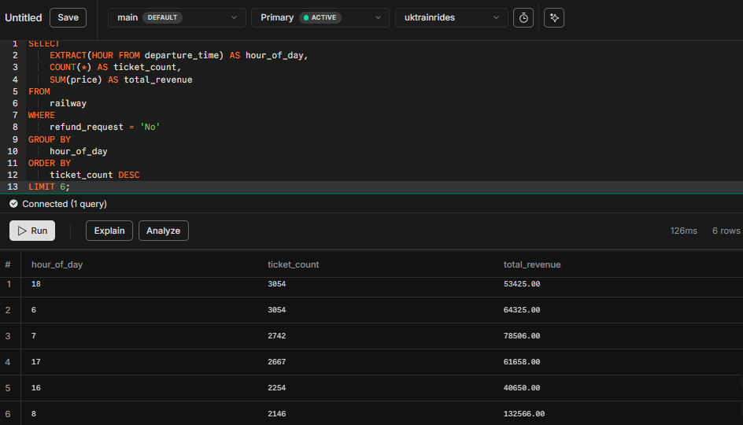
● How does ticket sales and revenue vary across peak and off-peak hours?
SELECT
CASE
WHEN CAST(departure_time AS TIME) BETWEEN '06:00:00' AND '08:00:00' THEN 'Morning Peak (6-8 AM)'
WHEN CAST(departure_time AS TIME) BETWEEN '16:00:00' AND '18:00:00' THEN 'Evening Peak (4-6 PM)'
ELSE 'Off-Peak'
END AS time_period,
COUNT(*) AS ticket_sales,
SUM(price) AS total_revenue
FROM railway
GROUP BY time_period
ORDER BY total_revenue DESC;
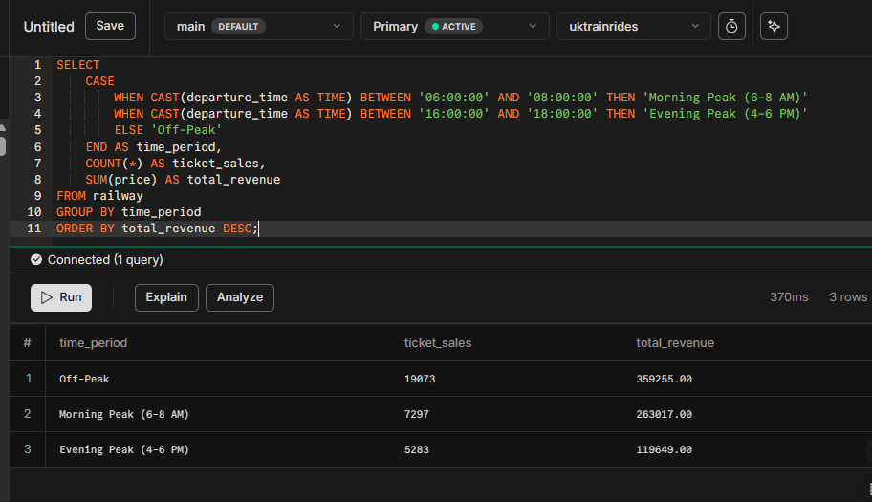

- Which payment method generates the highest number of transactions and revenue for railway ticket sales?
SELECT
purchase_type,
COUNT(*) AS tickets_count,
SUM(price) AS total_revenue
FROM
railway
WHERE
refund_request = 'No'
GROUP BY
purchase_type
ORDER BY
total_revenue DESC;
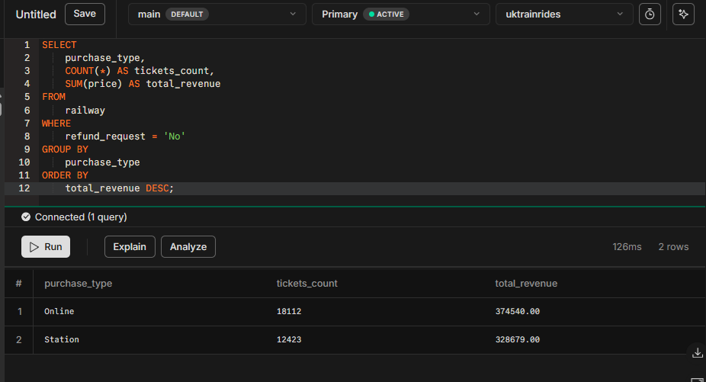

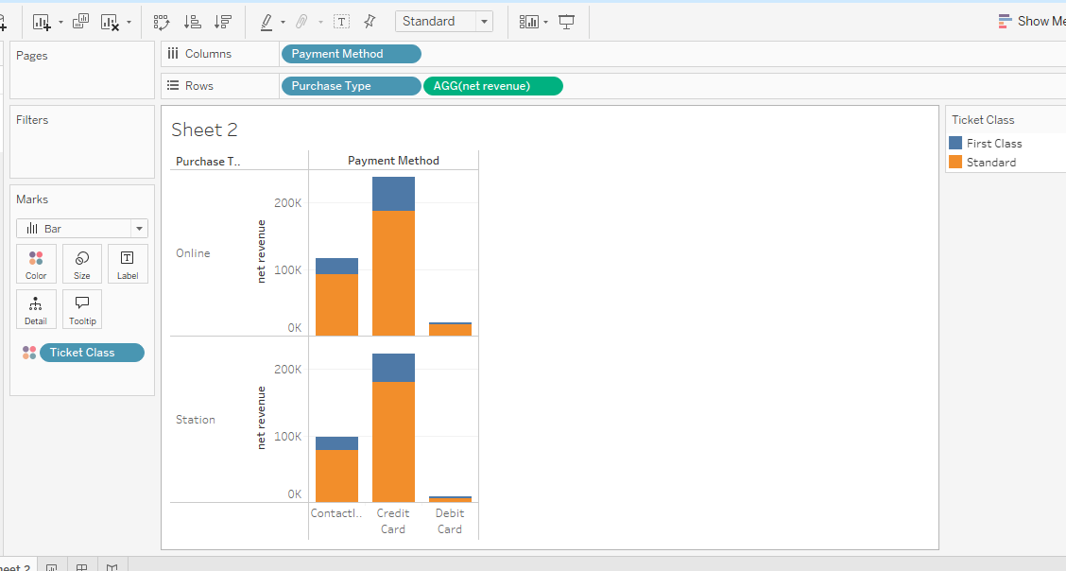

Key Insights
- Online transactions account for 59.31% of total transactions and generate the highest revenue (£374,540), indicating a strong preference for digital payments.
- Station transactions contribute 40.68% of the total transactions, generating £328,679, showing that physical locations remain a significant revenue source.
- The total revenue generated from all payment methods is £703,219, with a fairly balanced distribution between online and station sales.

Conclusion & Recommendations
- Online payments dominate, highlighting the importance of maintaining a seamless and secure digital payment system. Further enhancements, such as promotional discounts for online purchases, could boost digital adoption.
- Despite the rise of online payments, station transactions still contribute significantly. Ensuring efficient payment processing at stations will help maintain a smooth customer experience.
- Continuous monitoring of transaction trends will be valuable in optimizing both online and station-based payment strategies for maximum revenue growth.

3. Customer Behavior:
● What are the most crowded departure and arrival stations?
- The most crowded departure:
SELECT departure_station, COUNT(*) AS departure_trip_count
FROM railway
GROUP BY departure_station
ORDER BY departure_trip_count DESC
limit 1;
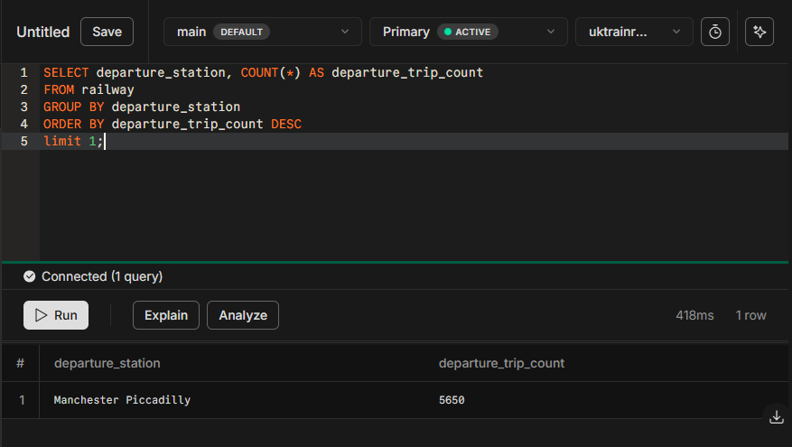
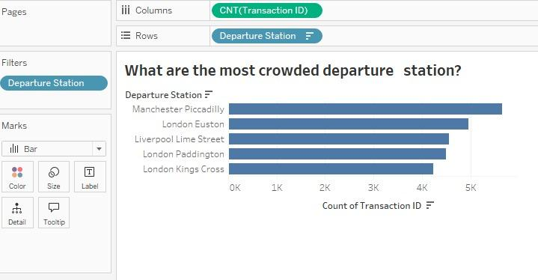
- The most crowded arrival:
SELECT arrival_destination, COUNT(*) AS arrival_trip_count
FROM railway
GROUP BY arrival_destination
ORDER BY arrival_trip_count DESC
limit 1;
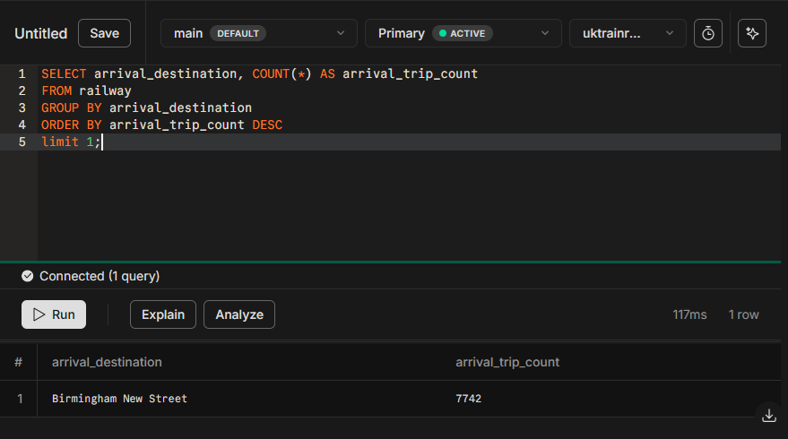
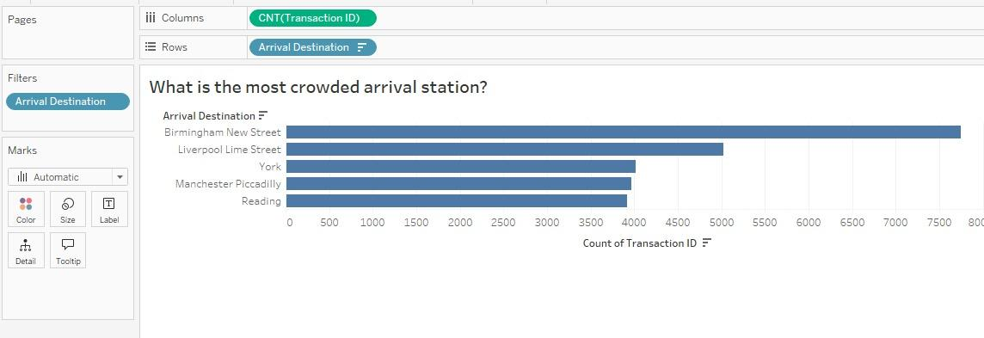
● Which railway lines have the highest passenger demand based on ticket sales?
SELECT
CONCAT(Departure_Station, ' - ', Arrival_Destination) AS railway_line,
COUNT(*) AS ticket_sales
FROM railway
GROUP BY railway_line
ORDER BY ticket_sales DESC;
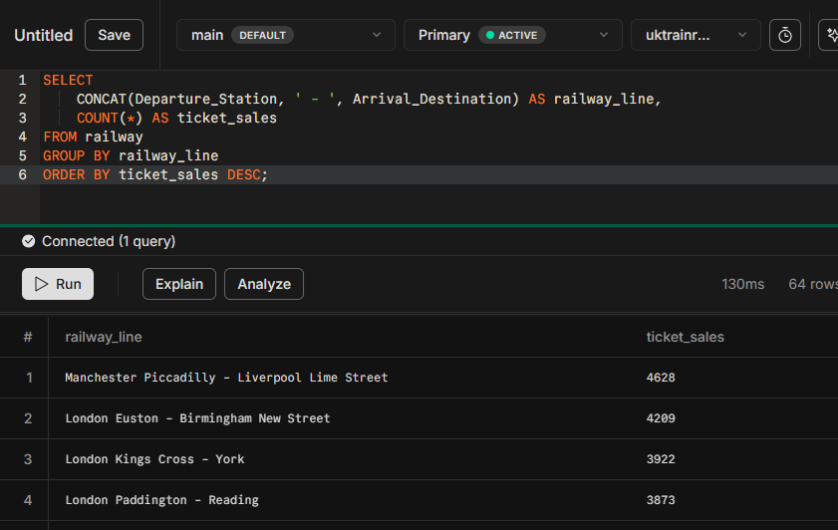
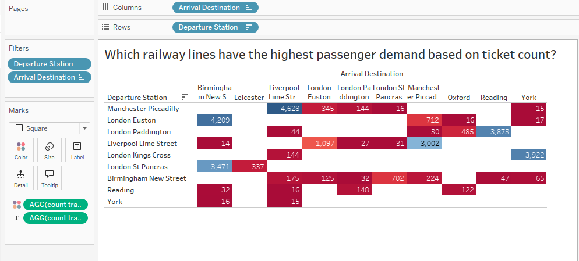
● What is the distribution of ticket types (Advance, Off-Peak, Anytime) purchased?
SELECT ticket_type,
COUNT(*) AS ticket_count,
ROUND((COUNT(*) * 100.0 / SUM(COUNT(*)) OVER()), 2) AS percentage
FROM railway
GROUP BY ticket_type
ORDER BY ticket_count DESC;
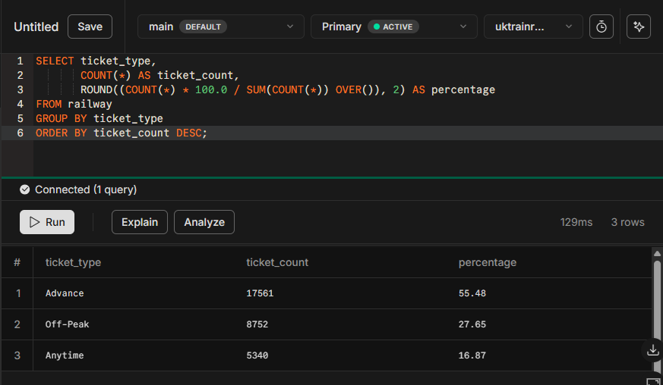
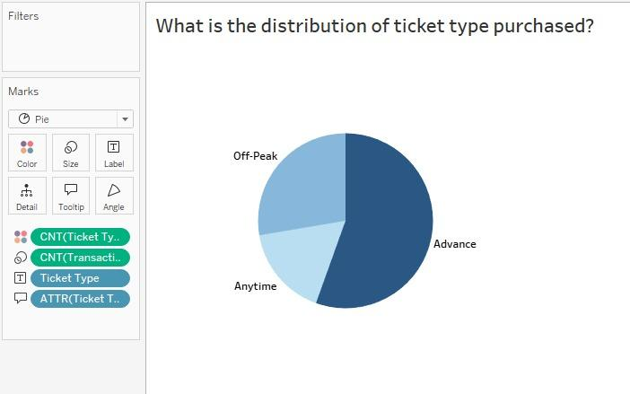
● How does the purchase time affect ticket prices?
SELECT EXTRACT(HOUR FROM purchase_time) AS purchase_hour,
ROUND(AVG(price), 2) AS average_price
FROM railway
GROUP BY purchase_hour
ORDER BY purchase_hour;
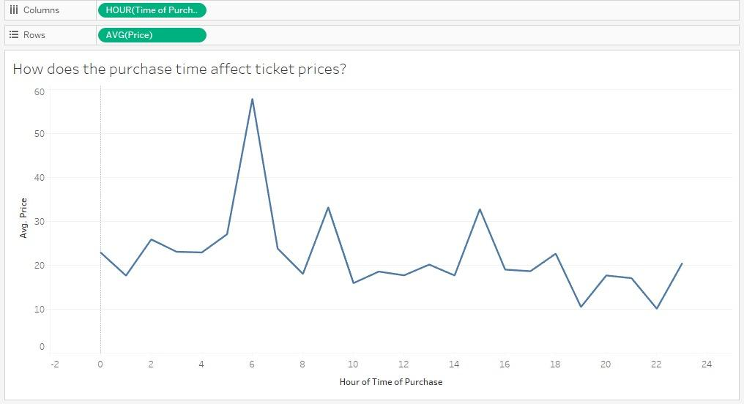
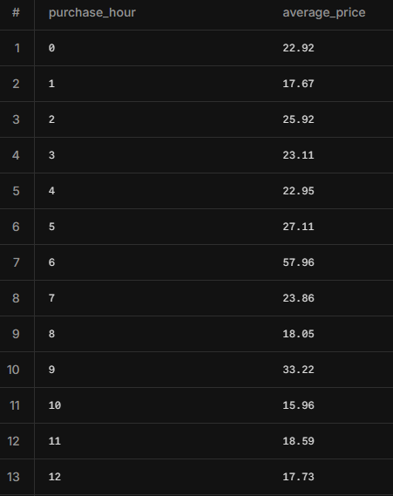
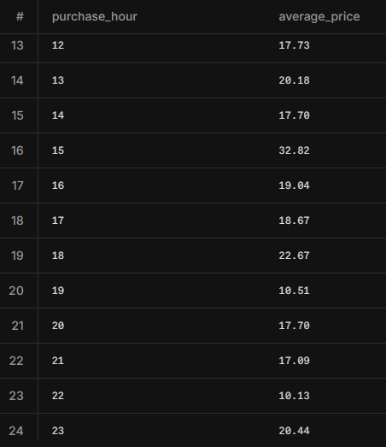

Interpretation of Results:
- If prices increase during specific hours (e.g., morning or peak hours), it suggests higher demand-driven pricing.

If prices decrease during certain times (e.g., late night or early morning), it indicates possible discounts for off-peak hours.

4. Demographic Insights:
● What is the distribution of rail card types (Adult, Senior, Disabled, etc.) used?
SELECT Rail_card,
COUNT(*) as count,
ROUND(100.0 * COUNT(*) / SUM(COUNT(*)) OVER(), 2) AS percentage
FROM railway
GROUP BY rail_card
ORDER BY count DESC;
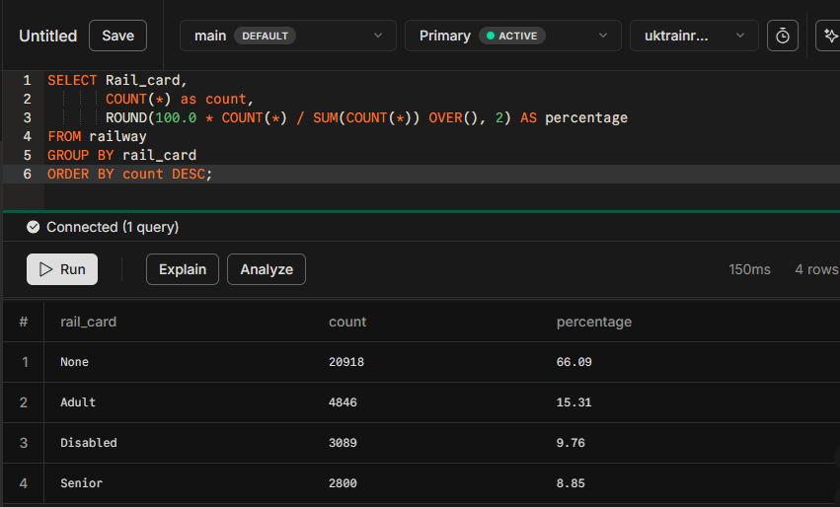
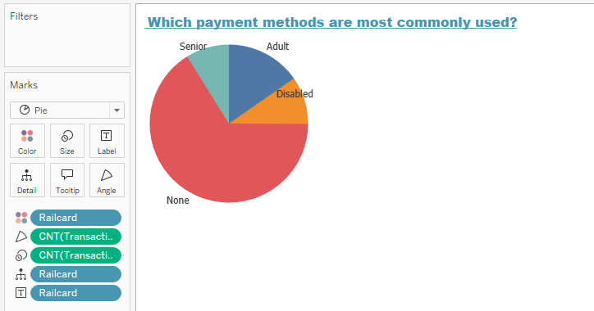
● Which payment methods are most commonly used?
SELECT payment_method, ticket_class, COUNT(*) AS purchase_count
FROM railway
WHERE refund_request = 'No'
GROUP BY payment_method, ticket_class
ORDER BY purchase_count DESC;
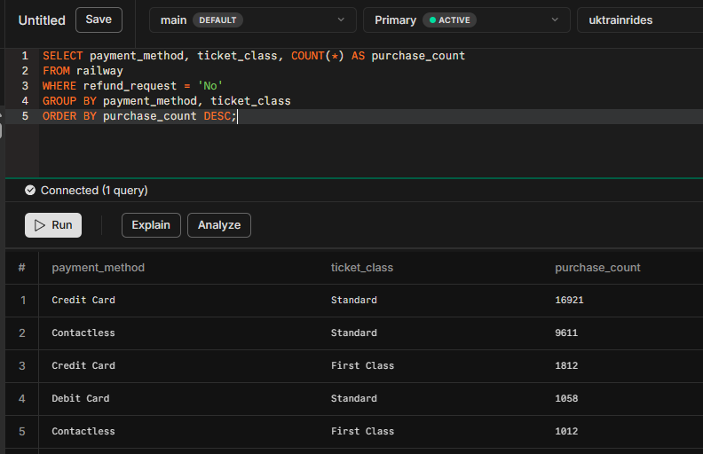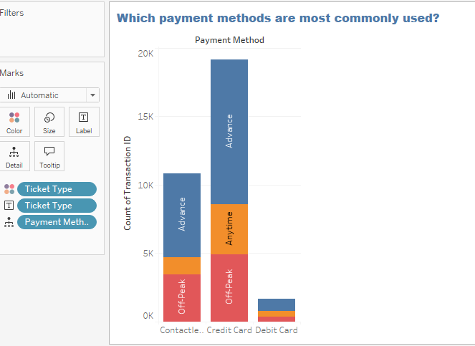

5. Route Analysis:
- Which routes are most profitable? → Highest revenue-generating routes.
Most five profitable routes
departure_station | arrival_destination | line_revenue
London Kings Cross | York | 183459
Liverpool Lime Street | London Euston | 113451
London Paddington | Reading | 65467
London Euston | Manchester Piccadilly | 61004
London St Pancras | Birmingham New Street | 52885

select departure_station ,arrival_destination , sum(price) as line_revenue
from railway
group by 1 ,2
order by 3 desc
limit 5

● Are there any routes with frequently high delays?
delay percentage for each route:
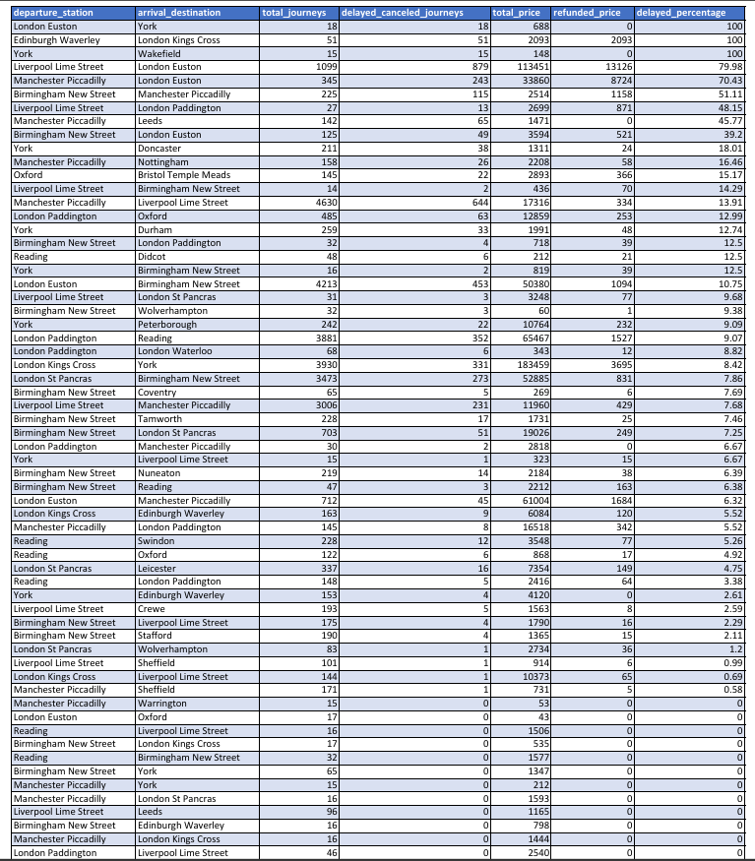
SELECT
departure_station,
arrival_destination,
COUNT(*) AS total_journeys,
SUM(CASE WHEN journey_status != 'On Time' THEN 1 ELSE 0 END) AS delayed_canceled_journeys,
SUM(price) AS total_price,
SUM(CASE WHEN refund_request = 'Yes' THEN price ELSE 0 END) AS refunded_price,
ROUND(
(SUM(CASE WHEN journey_status != 'On Time' THEN 1 ELSE 0 END) * 100.0) / COUNT(*),
2
) AS delayed_percentage
FROM railway
GROUP BY departure_station, arrival_destination
ORDER BY 7 DESC;

Relation between journey duration and revenue:
The following table shows that long duration journeys have ‘low revenue’
departure_station | arrival_destination | journey_duration | tickets_count | route_revenue
Birmingham New Street | Edinburgh Waverley | 04:30:00 | 16 | 798
Edinburgh Waverley | London Kings Cross | 04:20:00 | 51 | 2093
London Kings Cross | Edinburgh Waverley | 04:20:00 | 163 | 6084
Liverpool Lime Street | London Paddington | 02:30:00 | 27 | 2699
Liverpool Lime Street | London St Pancras | 02:30:00 | 31 | 3248
London Paddington | Liverpool Lime Street | 02:30:00 | 46 | 2540
Reading | Liverpool Lime Street | 02:30:00 | 16 | 1506
York | Edinburgh Waverley | 02:30:00 | 153 | 4120
Liverpool Lime Street | London Euston | 02:15:00 | 1099 | 113451
London Kings Cross | Liverpool Lime Street | 02:15:00 | 144 | 10373

select distinct departure_station,arrival_destination,
CASE
WHEN arrival_time < departure_time
THEN (arrival_time - departure_time) + INTERVAL '24 hours'
ELSE (arrival_time - departure_time)
END AS journey_duration , count(*), sum(price) as route_revenue
from railway
group by 1,2,3
order by 3 desc
limit 10

Correlation between journey duration and revenue:
It’s 0.1 which means there is no correlation between journey duration and revenue.
SELECT CORR(EXTRACT(EPOCH FROM journey_duration) / 3600, route_revenue) AS correlation
FROM (
SELECT
departure_station,
arrival_destination,
CASE
WHEN arrival_time < departure_time
THEN (arrival_time - departure_time) + INTERVAL '24 hours'
ELSE (arrival_time - departure_time)
END AS journey_duration,
SUM(price) AS route_revenue
FROM railway
GROUP BY 1, 2, 3
) AS subquery;

Routes with highest revenue and their duration

departure_station | arrival_destination | journey_duration | num_of_tickets | route_revenue
London Kings Cross | York | 01:50:00 | 3930 | 183459
Liverpool Lime Street | London Euston | 02:15:00 | 1099 | 113451
London Paddington | Reading | 01:00:00 | 3881 | 65467
London Euston | Manchester Piccadilly | 01:50:00 | 712 | 61004
London St Pancras | Birmingham New Street | 01:20:00 | 3473 | 52885
London Euston | Birmingham New Street | 01:20:00 | 4213 | 50380
Manchester Piccadilly | London Euston | 01:50:00 | 345 | 33860
Birmingham New Street | London St Pancras | 01:20:00 | 703 | 19026
Manchester Piccadilly | Liverpool Lime Street | 00:30:00 | 4630 | 17316
Manchester Piccadilly | London Paddington | 02:15:00 | 145 | 16518

select distinct departure_station,arrival_destination,
CASE
WHEN arrival_time < departure_time
THEN (arrival_time - departure_time) + INTERVAL '24 hours'
ELSE (arrival_time - departure_time)
END AS journey_duration , count(*) as num_of_tickets, sum(price) as route_revenue
from railway
group by 1,2,3
order by 5 desc
limit 10

Insights by departure stations
Overview

departure_station | count | traffice_percentage | total_sales
Manchester Piccadilly | 5653 | 17.84 | 75406
London Euston | 4960 | 15.65 | 112115
Liverpool Lime Street | 4567 | 14.41 | 135436
London Paddington | 4510 | 14.23 | 84027
London Kings Cross | 4237 | 13.37 | 199916
London St Pancras | 3893 | 12.28 | 62973
Birmingham New Street | 2139 | 6.75 | 38143
York | 928 | 2.93 | 19554
Reading | 594 | 1.87 | 10127
Oxford | 145 | 0.46 | 2893
Edinburgh Waverley | 51 | 0.16 | 2093
Bristol Temple Meads | 16 | 0.05 | 98

select distinct departure_station ,COUNT(*) as count,ROUND(100.0 * COUNT(*) / SUM(COUNT(*)) OVER(), 2) AS traffice_percentage, SUM(price) as total_Sales
from railway
group by 1
order by 2 desc

- The Birmingham New Street
Birmingham New Street has fourteen arrival stations with total sales of 38143 pounds.
The Birmingham New Street ,Edinburgh Waverley route has 16 journeys with 4:30 hours long and total revenue of 798 $
Every journey has just one passenger
And journey dates aren’t regularly distributed as shown in the table
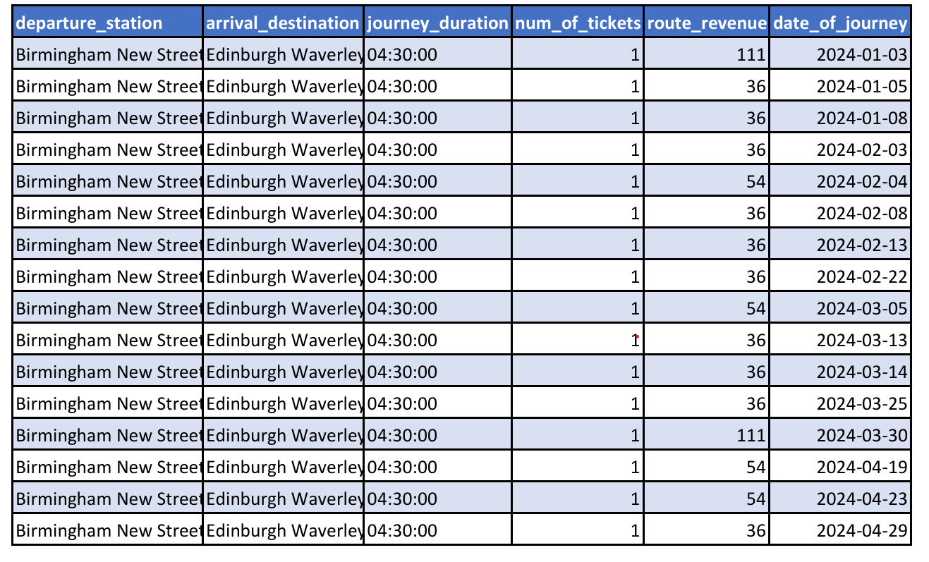
with jd as (select distinct departure_station,arrival_destination,
CASE
WHEN arrival_time < departure_time
THEN (arrival_time - departure_time) + INTERVAL '24 hours'
ELSE (arrival_time - departure_time)
END AS journey_duration , count(*) as num_of_tickets, sum(price) as route_revenue,date_of_journey
from railway
group by 1,2,3,6
order by 3 desc
limit 16)
select * from jd
order by date_of_journey

Arrival station | No. journeys | No.tickets | Sales
Edinburgh Waverley | 1 | 16 | 798
York | 1 | 65 | 1347
Liverpool Lime Street | 11 | 175 | 1790
London Kings Cross | 1 | 17 | 535
London Paddington | 2 | 32 | 718
Reading | 3 | 47 | 2212
London Euston | 7 | 125 | 3594
London St Pancras | 11 | 703 | 19026
Manchester Piccadilly | 2 | 225 | 2514
Stafford | 3 | 190 | 1365
Coventry | 1 | 65 | 269
Nuneaton | 2 | 219 | 2184
Tamworth | 2 | 228 | 1731
Wolverhampton | 1 | 32 | 60

- Edinburgh Waverley
Edinburgh Waverley has one arrival station with total sales of 2093 pounds.
Route( Edinburgh Waverley ,London Kings Cross)
This route has more than two journeys a week with 27 tickets from 3/1/2024 to 26/4/2024 with total sales of 2093 pound which is very low revenue
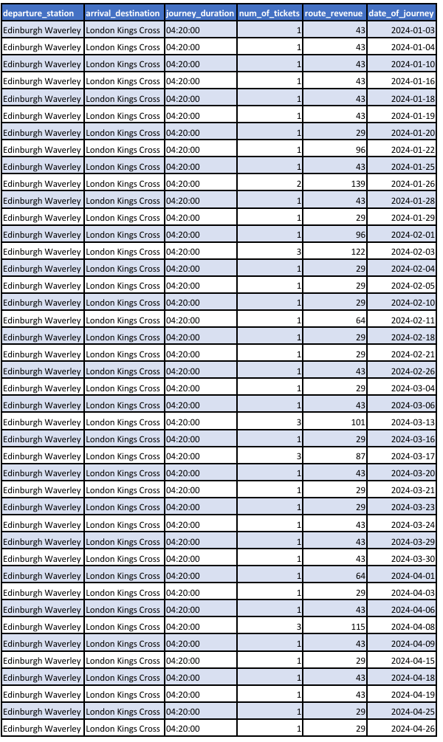
with jd as (select distinct departure_station,arrival_destination,
CASE
WHEN arrival_time < departure_time
THEN (arrival_time - departure_time) + INTERVAL '24 hours'
ELSE (arrival_time - departure_time)
END AS journey_duration , count(*) as num_of_tickets, sum(price) as route_revenue,date_of_journey
from railway
group by 1,2,3,6
order by 3 desc
)
select * from jd
where departure_station ='Edinburgh Waverley' and arrival_destination ='London Kings Cross'
order by date_of_journey

- London Kings Cross
London Kings Cross has three arrival stations with total sales of 199916 pounds.
Route( London Kings Cross, Edinburgh Waverley )
This route has more than five journeys a week with 1 journeys from 3/1/2024 to 30/4/2024 with total sales of 6085 pound which is very low revenue
with jd as (select distinct departure_station,arrival_destination,
CASE
WHEN arrival_time < departure_time
THEN (arrival_time - departure_time) + INTERVAL '24 hours'
ELSE (arrival_time - departure_time)
END AS journey_duration , count(*) as num_of_tickets, sum(price) as route_revenue,date_of_journey
from railway
group by 1,2,3,6
order by 3 desc
)
select * from jd
where departure_station = 'London Kings Cross' and arrival_destination ='Edinburgh Waverley'
order by date_of_journey

Route( London Kings Cross, York )
This route has more than seven journeys a week with 60 journeys and 3930 tickets from 16/12/2023 to 6/4/2024 with total sales of 183459 pounds which is most profitable revenue that is about 24.7 % from all UK rail way sales for the same period.
with jd as (select distinct departure_station,arrival_destination,
CASE
WHEN arrival_time < departure_time
THEN (arrival_time - departure_time) + INTERVAL '24 hours'
ELSE (arrival_time - departure_time)
END AS journey_duration , count(*) as num_of_tickets, sum(price) as route_revenue,date_of_journey
from railway
group by 1,2,3,6
order by 3 desc
)
select * from jd
where departure_station = 'London Kings Cross' and arrival_destination ='York'
order by date_of_journey
Route( London Kings Cross, Liverpool Lime Street )
This route has in average 4.9 journeys a week with 7 journeys and 144 tickets from 2/1/2024 to 28/4/2024 with total sales of 10373 pound which is low revenue
with jd as (select distinct departure_station,arrival_destination,
CASE
WHEN arrival_time < departure_time
THEN (arrival_time - departure_time) + INTERVAL '24 hours'
ELSE (arrival_time - departure_time)
END AS journey_duration , count(*) as num_of_tickets, sum(price) as route_revenue,date_of_journey
from railway
group by 1,2,3,6
order by 3 desc
)
select * from jd
where departure_station = 'London Kings Cross' and arrival_destination ='Liverpool Lime Street'
order by date_of_journey

- Liverpool Lime Street:
Liverpool Lime Street has eight arrival stations with total sales of 135436 pounds.
Arrival station | No. journeys | No.tickets | Sales
Birmingham New Street | 1 | 14 | 436
Crewe | 3 | 193 | 1563
Leeds | 5 | 96 | 1165
London Euston | 11 | 1099 | 113451
London Paddington | 2 | 24 | 2699
London St Pancras | 2 | 31 | 3248
Manchester Piccadilly | 69 | 3006 | 11960
Sheffield | 3 | 101 | 914

From the previous table , it’s obvious that the route Liverpool Lime Street to London Euston is the most profitable route for the same departure station with 113451 pounds , that is about 15.3 % from all UK rail way sales for the same period.This route has a percentage of delay equals 79% of the total route
The next most profitable route for the same departure station with 11960 pounds and the most number of tickets (3006 ticket ) ,for the same period.
- London Euston
London Euston has four arrival stations with total sales of 112115 pounds.
Arrival station | No. journeys | No.tickets | Sales
Manchester Piccadilly | 16 | 712 | 61004
York | 1 | 18 | 688
Birmingham New Street | 62 | 4213 | 50380
Oxford | 1 | 17 | 43
- Bristol Temple Meads
Bristol Temple Meads has one arrival station with total sales of 98 pounds.
This route has on average one journey a week with16 tickets from 25/1/2024 to 18/4/2024 with total sales of 98 pounds which is low revenue.
- London Paddington
London Paddington has five arrival stations with total sales of 84027 pounds.
Arrival station | No. journeys | No.tickets | Sales
Manchester Piccadilly | 2 | 30 | 2818
London Waterloo | 1 | 68 | 343
Reading | 60 | 3881 | 65467
Oxford | 1 | 485 | 12859
Liverpool Lime Street | 3 | 46 | 2540

- London St Pancras
London St Pancras has three arrival stations with total sales of 62937 pounds
Arrival station | No. journeys | No.tickets | Sales
Leicester | 2 | 337 | 7354
Wolverhampton | 2 | 83 | 2734
Birmingham New Street | 61 | 3473 | 52885

- Manchester Piccadilly
Manchester Piccadilly has ten arrival stations with total sales of 75406
Pounds
Arrival station | No. journeys | No.tickets | Sales
London Kings Cross | 1 | 16 | 1444
London Paddington | 6 | 145 | 16518
London St Pancras | 1 | 16 | 1593
London Euston | 12 | 345 | 33860
York | 1 | 15 | 212
Nottingham | 2 | 158 | 2208
Leeds | 5 | 142 | 1471
Sheffield | 10 | 171 | 731
Liverpool Lime Street | 64 | 4630 | 17316
Warrington | 1 | 15 | 53

From the previous table , it’s obvious that the route Manchester Piccadilly to Liverpool Lime Street has the most occupancy rate with 4630 ticket , that is about 15 % from all UK rail way tickets count for the same period.This route has a percentage of delay equals 14% of the total route

- Oxford
Oxford has one arrival station with total sales of 2893 Pounds.
- Manchester Piccadilly
Manchester Piccadilly has six arrival stations with total sales of 10127 Pounds.
Arrival station | No. journeys | No.tickets | Sales
Liverpool Lime Street | 15 | 16 | 1506
Birmingham New Street | 29 | 32 | 1577
Swindon | 95 | 228 | 3548
London Paddington | 82 | 148 | 2416
Oxford | 79 | 122 | 868
Didcot | 42 | 48 | 212

- York
York has eight arrival stations with total sales of 19554 Pounds.
Arrival station | No. journeys | No.tickets | Sales
Edinburgh Waverley | 8 | 153 | 4120
Birmingham New Street | 1 | 16 | 819
Liverpool Lime Street | 4 | 15 | 323
Peterborough | 1 | 242 | 10764
Durham | 4 | 259 | 1991
Doncaster | 2 | 211 | 1311
Leeds | 1 | 17 | 78
Wakefield | 1 | 15 | 148
- Occupancy Rate: The proportion of available seats filled by routes
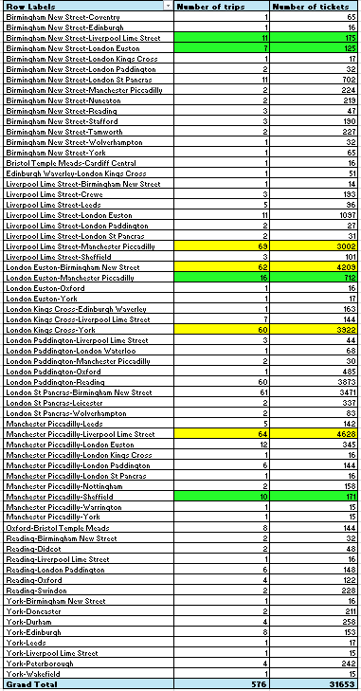
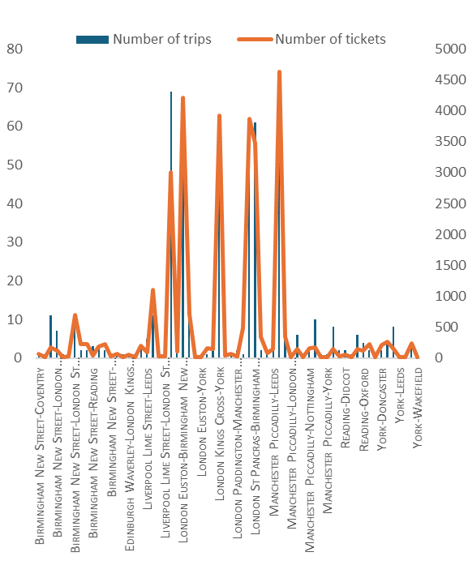
From the previous table , it’s obvious that the route Manchester Piccadilly to Liverpool Lime Street , London Euston to Birmingham New Street and London Kings Cross to York have the highest occupancy rate with number of trips about 60 trips ,with average passenger number per trip (72) and average revenue per trip 1900 pound ,while Manchester Piccadilly to Sheffield, Birmingham New Street to Liverpool Lime Street have the lowest occupancy rate with number of trips about 10 trips ,with average passenger number per trip (72) and average revenue per trip 70 pound

● Which routes are the most frequently traveled
SELECT
departure_station,
arrival_destination,
COUNT(*) AS total_journeys,
SUM(CASE WHEN journey_status != 'On Time' THEN 1 ELSE 0 END) AS delayed_canceled_journeys,
SUM(price) AS total_price,
SUM(CASE WHEN refund_request = 'Yes' THEN price ELSE 0 END) AS refunded_price,
ROUND(
(SUM(CASE WHEN journey_status != 'On Time' THEN 1 ELSE 0 END) * 100.0) / COUNT(*),
2
) AS delayed_percentage
FROM railway
GROUP BY departure_station, arrival_destination
ORDER BY 3 DESC
LIMIT 10;
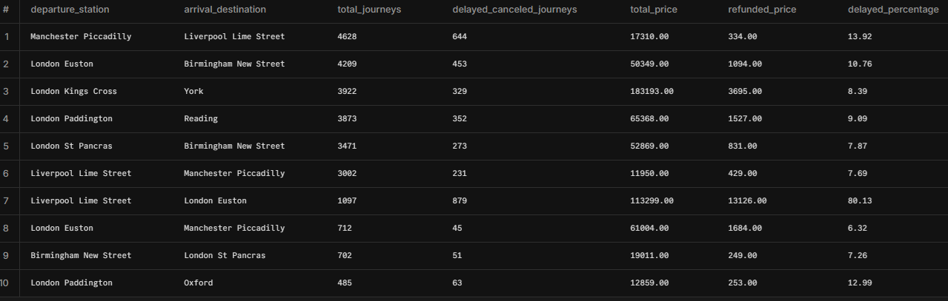
● What is the average journey duration for different routes?
SELECT
departure_station,
arrival_destination,
ROUND(AVG(
EXTRACT(EPOCH FROM
CASE
WHEN arrival_time < departure_time
THEN (arrival_time - departure_time) + INTERVAL '24 hours'
ELSE (arrival_time - departure_time)
END
) / 60), 2) AS avg_journey_duration_minutes
FROM railway
GROUP BY departure_station, arrival_destination
ORDER BY avg_journey_duration_minutes DESC;
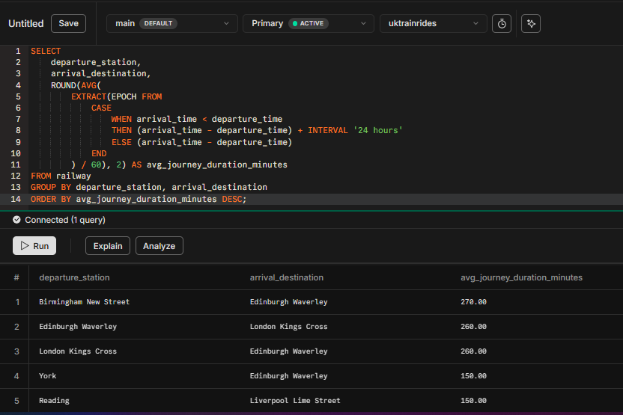

Project Progress Report:

Team Formation & Initial Steps:
- The group was formed on February 4.
- A voting process was initiated to select the tools to be used.
- The first meeting was held to discuss potential project ideas.

Project Selection & Planning:
- The second meeting took place on February 10 to finalize the project selection.
- On February 11, a voting process was launched to choose the project name.

Design & Preparation Phase:
- On February 17, team members submitted proposals for the team logo, and a meeting was held to finalize the mockups and agree on the business questions.
- From February 17 to February 21, near-daily meetings were conducted, leading to the completion of the mockups and finalization of the business questions.

Execution Phase:
- On February 25, the team started data cleaning, and tasks were distributed among members.

Finalization & Submission:
- On March 23, an initial announcement was made on LinkedIn regarding the project's near completion.
https://www.linkedin.com/posts/dra7med7ussein_depi-digitalegypt-graduationproject-activity-7309297046245597184-mOeW?utm_source=share&utm_medium=member_desktop&rcm=ACoAAA5cLkABu7HUe2ns1K6N3BfxVY9YysLDyFw
- On March 26, the team successfully completed and submitted the Graduation Project Initial Submission.

 | 
 | 

 | 

Screen from our group meeting:



- initial announcement



